Union County
We’re Connected to You!

A Service of
The Board of
Chosen Freeholders

UNION COUNTY
OFFICE OF CULTURAL & HERITAGE AFFAIRS
DEPARTMENT OF PARKS & RECREATION

UNION COUNTY HISTORY GRANT PROGRAM

GENERAL OPERATING SUPPORT GRANT

GUIDELINES and APPLICATION

Calendar Year 2018

January 1, 2018 – December 31, 2018

Operating support grants are available only to Union County nonprofit history organizations. General assistance is provided to historical societies, history museums
and historic sites with collections or programming relating to the history of New Jersey. Eligibility expenses include, but are not limited to the following:

Salaries and wages
Contracted services/outside fees and services
Maintenance of collections
Professional development, staff and volunteer training
Printing, publicity, marketing
Postage and telephone
Equipment purchase, installation or lease
Development
HVAC operating expenses

Funding for this program is made available through the
New Jersey Historical Commission, a division of the
Department of State

UNION COUNTY HISTORY GRANT PROGRAM
Calendar Year 2018: January 1, 2018 – December 31, 2018

INTRODUCTION

The Union County Board of Chosen Freeholders is pleased to offer the Union County History Grant Program. The Union County Office of Cultural & Heritage Affairs (UCOCHA), Department of Parks and Recreation, administers the history grant program funded by the New Jersey Historical Commission (NJHC).

The Guidelines and Application describe how grant funds are used to support special projects or general operating expenses of Union County based non-profit history organizations and units of local government, including libraries and schools that meet the NJHC priorities and criteria.

The Union County Office of Cultural and Heritage Affairs affirms the priorities of the NJHC:

- Help strengthen and further develop existing New Jersey history organizations and programs
- Initiate new programming on New Jersey history
- Improve management and interpretation of historic sites and historical collections
- Expand public understanding and awareness of historical resources
- Increase public and organizational participation in historical programs and activities
- Increase accessibility of historical resources to diverse communities and encourage the exploration of understudied and multicultural aspects of New Jersey history
- Increase the body and quality of information on New Jersey history available to the public
- Preserve materials for the study or preservation of New Jersey history

PROGRAM TIMELINE
Wednesday, April 19 Grant Writing Workshop
Friday, May 26 Deadline for application draft
(Required of first time applicants)
Friday, June 23 Application Deadline
July/August Professional reviewers, C& H Programs Advisory Board Review
September Notification of Awards

For further information contact John W. Prescott, Union County Office of Cultural & Heritage Affairs, 908-436-2912 or jprescott@ucnj.org.

The application is available via e-mail as a writeable Word document (Microsoft Office 2000). Only hard copies of the application may be submitted.

Funding for this program is made available through the
New Jersey Historical Commission, a division of the
Department of State.

General Eligibility Requirements

- Union County based, non-profit history organizations must
- have collections or programming relating to Union County or local history
- be incorporated in the state of New Jersey
- be defined as a non-profit organization under section 501(c) (3) or 501(c ) (4) by the Internal Revenue Service, or pending same
- have been in existence at least two years and demonstrate an ability to provide history programs and/or services to the public

B. Units of government, including schools and libraries, must
- provide Union County or local history programs, services or activities
- describe in detail the portion of the applicant’s work related to the proposed history program/project

C. Union County based non-history/non-profit organizations must
- be incorporated in the State of New Jersey
- have been in existence at least two years
- be defined as a non-profit organization under section 501(c) (3) or 501(c) (4) of the Internal Revenue Service, or pending same.
- include a copy of the organization’s IRS letter of determination in the original application
packet only
- describe in detail the programs, services and activities that relate to the proposed history program/project
3
Grant recipients must comply with all applicable state and federal laws and maintain good standing with all required state and federal filings. Applicants must show that grant funds will permit them to expand, enhance or introduce Union County and/or local history programs or services. Organizations may not use grant monies as a means to reduce their own expenditures on history programs or services by using these funds as replacement funds.

- Organizations applying for funding under the 2017 Union County Local Arts Grant Program or 2016 HEART Grant Program, may apply to The Union County History Grant Program.

ADDITIONAL REQUIREMENTS

Credit Line: All funded projects must include the following credit line on all printed and publicity materials: This program is made possible by a grant from the New Jersey Historical Commission, a division of the Department of State, and administered by the Union County Office of Cultural & Heritage Affairs.

Technical Assistance Workshops: Grant recipients are expected to attend at least one technical assistance workshop presented by the Office during the grant year.

Cultural Events Calendar: Information on all funded activities must be sent to the Office for inclusion in the calendar of events as soon as program dates are firm, preferably 3 months in advance of the date of the event. Request a “Cultural Events” form at 908-558-2550 or a writeable form at culturalinfo@ucnj.org.

REVIEW PROCESS

Staff will review and check for completeness of applications received prior to the mandatory deadline. A professional panel will evaluate all proposals against the stated criteria included with these guidelines. The Cultural and Heritage Programs Advisory Board will review applications, professional panel evaluations and determine award amounts. Applicants will be notified of their standing in early fall. Contracts will be signed in September.

DEADLINES

First time applicants are required to submit a draft of their application by Friday, May 26, 2017 for staff review. The narrative and budget pages may be emailed or faxed 908-558-2652. Applicants must submit one original and four copies of the final application and support materials to the Union County Office of Cultural & Heritage Affairs, 633 Pearl Street, Elizabeth, NJ 07202. Application Deadline: Friday, June 23, 2017.

REPORTING AND GRANT PAYMENTS
An Interim Report is due July 6, 2018, covering the period from January 1, 2018 through June 30, 2018. The report must contain a financial accounting and narrative for this period. Should the organization plan any change in the project or expenditure for the remainder of the grant period, the report must address those changes. If the project has been completed, the Final Report may be submitted instead.

A Final Report is due December 5, 2018, and must include a financial accounting and a narrative of activities for the entire grant period of January 1, 2018 through December 31, 2018. If there has been any material change in the organization (staffing, management, facilities and finances) since the award, the final report must discuss those changes

Documentation of all grant and match expenses must be in the form of paid receipts, canceled checks, or print out of an accounting program (e.g. Quicken) and submitted with the Interim and Final Reports at the end of the grant cycle. Time record sheets may document in-kind donations for volunteer hours; statements of value document donated goods and services. Whether used for “match” purposes or not, in-kind donations must be noted.
Grant funds will be disbursed in two payments. Seventy-five percent will be paid after the contract is signed. After receipt of an acceptable final report, a final payment of 25% of the award will be made. The final payment is a reimbursement payment!
Non-compliance with these requirements and terms may affect both current and future funding.

APPEALS PROCESS
An appeal to the History Grant Program will be entertained only if an applicant can specifically demonstrate that an application was misinterpreted or misunderstood during the evaluation process. The amount of an award will not be grounds for an appeal, and the appeal must be made only on the basis of the information contained in the initial application. Office staff will clarify the appeals procedure for any applicant requiring further information.
General Operating Support Guidelines
The Maximum General Support Operating request is $5,000. Request cannot exceed 1/3/ or 33% of the organization’s budget. Grant funds help underwrite virtually all operating aspects of an organization offering New Jersey history services and need not be applied to any one aspect, program, service, or expense. The list of eligible and ineligible expenses is provided to put organizations on notice as to what will be permitted.
Eligible Expenses
- Salaries and wages

- Contracted services/outside fees and services

- Printing, publicity, marketing

- Postage and telephone

- Fundraising and development

- Staff training

- Lease expenses

- Mortgage interest

- Equipment purchase, installation, and lease (e.g., computers, office furnishings, files)

- Utilities and HVAC (purchase, installation, and operational costs of heating, ventilation, and air conditioning)

- Maintenance of collections and the interiors of structures (Note: Interior construction is not considered maintenance and is not an eligible expense.)

- Basic grounds maintenance

- Travel and transportation (automobile travel @$.31/mile, train, or air coach travel)

- Insurance

- Licensing and registration fees (e.g., New Jersey charities registration)

- Planning for compliance with the Americans with Disabilities Act

- Long-term and strategic planning

- Audits
Ineligible Expenses
- Capital improvements, including the construction of structures and work such as roofing, replacement of gutters, windows, doors, and the removal or addition of interior walls, and major landscaping projects

- Exterior maintenance

- Purchase of real estate, motor vehicles, or leasehold improvements

- Acquisitions (including artifacts and collections)

- Weapons (historic or reproduction), ammunition or any other items that can be used to inflict bodily harm

- Hospitality (refreshments)

- Deficits and debt service

- Retroactive funding

- Endowment

- Mortgage or loan principal

- Scholarships/prizes

UNION COUNTY HISTORY GRANT PROGRAM

Calendar Year: January 1, 2018 – December 31, 2018

General Operating Support Grant Application
Please read the Guidelines before completing the Application. Return one original and 4 copies (total 5) of the completed application to: Union County History Grant Program, Office of Cultural and Heritage Affairs, 633 Pearl Street, Elizabeth, NJ, 07202. This application is available as a writeable Word Document (Microsoft Office 2000). Questions: (908) 558-2550; NJ Relay Users 711. Deadline: Friday, June 23, 2017.
Applicant/Organization:
Address:
Phone#: ( ) Fax: ( )
E-mail:
Website:
Contact Person: Title:
Address:
Phone: ( ) Fax: ( )
Email:
Federal Tax Exemption #:
Total Grant Request: $
Summary of how grant funds will be spent
(No more than 100 words)

GOS Budget Summary
Complete this section last! All figures should be rounded to the nearest dollar.

Grant Amount Requested $

1: 3 Cash Match Requirement $
(For every dollar awarded, the applicant must match it with $3.00)

TOTAL COST (grant amount request + cash match requirement) $

Match Requirements

GOS grants require a 1:3 “cash match” which represents the organization’s share of the total cost shown in the application budget. Applicants may apply for grants up to 1/3 of the organization’s operating budget. The entire cash match is the balance of the budget and may come from any source except New Jersey State funds.
Example

Cash Match

Grant

If the organization’s current budget is $22,500, the organization may apply for $4,000 for a total budget of $26,500. This is an example only. Please use your organization’s budget numbers!

Current budget $22,500 program, staff support, operating expenses
Grant request 4,000 new staff, programs, services
Proposed budget $26,500 shows growth/depth

Authorization

I understand that these pages and attachments constitute part of this application. I certify that all statements in this application are true to the best of my knowledge; and I hereby release the Board of Chosen Freeholders of the County of Union, its employees, and agents from any liability and/or responsibility concerning any submission of materials to the program. I further certify that any funds received under the Union County History Grant Program will be used exclusively for the purpose set forth in this application. I understand and agree that submission of an application signifies intention to comply with Title VII of the Civil Rights Act of 1964 (PL 88-352), with Labor Standards under Section 501 of the National Foundation on the Arts and Humanities Act of 1965 (PL 185-209), Title IX of the Education Amendments of 1972, Section 504 of the Rehabilitation Act of 1973, and the Americans with Disabilities Act of 1990.

Authorizing Signature ______________________ Title ___________________

Date__________________________

General Operating Support Budget Form
Explain any line item fluctuations in excess of 20% from year to year.
INCOME CATEGORY | 16/ Actual | 17/ Projected | Cal 18/ Projected
Memberships
Store/Shop/Publications
Program Admissions
Grants (list sources on an attached sheet)
New Jersey Historical Commission
Other Government
Corporate/Foundation
Individual Contributions
Other Cash-(list source)

UC History Grant Program
TOTAL
EXPENSE CATEGORY | 16/ Actual | 17/ Projected | Cal 18/ Projected
Staff (salaries/wages/benefits)
Consultants
Speakers
Publicity and Marketing
Printing
Supplies
Telephone
Utilities
Postage
Facility Maintenance

Equipment Rental/Purchase
Space Rental
Lease /Mortgage
Insurance
Audit
Travel
Other (specify)

Other (specify)

TOTAL

Narrative Questions

Use the BOLDFACE words below, in the order in which they appear, as section headings in your narrative. Following this outline will help you develop a clear and concise narrative.

- What is the MISSION of your organization? List its goals and objectives. Provide an overview of the organization (e.g., location, age, size, membership; mention contents of collections, archives, etc.). Describe the demographics of the area from which the current audiences are primarily drawn.
- Describe the FACILITIES out of which your organization operates or for which it has custodial and interpretative responsibility. If you do not own the building, explain your relationship to the owner. Describe the arrangements regarding use and maintenance, including financial responsibilities. Remember to include floor and, if necessary, site plans.
For each of the following questions, explain how a grant will help your organization strengthen, expand, diversify and/or attain greater long-term stability in each of the following areas. For example, if the request is for personnel support, describe what those individuals will do, their history credentials and how their work will help strengthen the organization. Provide a similar rationale for each of the other requests.
- Describe the current essential PROGRAMS and SERVICES of your organization (including exhibitions and public programming). Be very specific about the benefits of each activity and the expenditures that will occur in the grant period.
- What are the HUMAN RESOURCES of your organization? Tell about your board. How is it formed, and what are its duties? List its executive committee members and describe their backgrounds. Tell about your volunteers, their experience, skills and responsibilities. Talk about the current staff (if applicable), their experience, skills, and responsibilities. Be very specific about requests for personnel: include job descriptions and resumes of potential candidates, if available.
- What are your MARKETING and AUDIENCE DEVELOPMENT strategies? Describe the methods currently used to attract audiences. Describe plans to expand and diversify your audiences. How many people visit your site annually? What are your current public hours?
- Is there a LONG-RANGE PLAN? If so, discuss the long-range plan and how this funding will help your organization implement its goals. Include a copy of your Long Range Plan with support materials.
- How is the money that currently FUNDS your organization raised? Where does it come from? What are your plans to broaden and diversify your base of funding? List, if any, the names of major corporate or foundation donors.
H. In a Financial Narrative, describe in words the major line items listed on the budget pages. Give specific information to support your request for funds. Explain any fluctuations in excess of 20% on any line item in the budget from year to year.
I. How will you EVALUATE the success and benefits of your programs? Describe how you will determine whether or not you succeeded in strengthening your organization.
J. How does your organization comply with the AMERICANS WITH DISABILITIES ACT (ADA) with regard to accessibility of the facilities where the project or program will take place? Identify ADA accommodations such as assistive listening devices, audio description, videotapes, large print programs, exhibit labels, etc. Mention your accomplishments or plans in the area of the accessibility to persons with disabilities.
K. What are your activities concerning EDUCATION and PUBLIC AWARENESS (Advocacy)? Tell how your programs promote the value of history education. Discuss ways in which they will expand public awareness of history resources.
EVALUATION CRITERIA

A professional history panel and the history committee of the UCOCHA Advisory Board will review each application using the following standards:

History Content
- Credentials of personnel as demonstrated by support material and resumes
- Activities that further the applicant’s history related goals and objectives
- Projects that promote education, awareness and appreciation for the importance of local and county history

Administrative Ability
- Exhibits sound management (volunteer or paid)
- Demonstrates ability to deliver services effectively
- Documents interest from intended audience (explains how projects are selected)

Financial Management
- Demonstrates fiscal responsibility
- Presents a realistic budget
- Shows diverse funding sources

Outreach and Promotion
- Demonstrates effective and timely publicity efforts that widely promote the organization and activities
- Demonstrates effort to involve individuals and groups from a diversity of backgrounds and communities
- Demonstrates effort to provide local and Union County history programs and activities with culturally diverse historic content and appeal to underserved communities
- Addresses accessibility issues in compliance with the Americans with Disabilities Act (ADA)

For your additional information:

History content may be demonstrated by support material – bios and resumes – by what you do or by what the people you hire do. Be clear about the history credentials of the personnel, both professional and volunteer, involved in your program.

Administrative capacity will be demonstrated by the organization of your proposal, its content, neatness and completeness. Accurate budget calculations are important; be sure to check your addition. Planning documents are helpful.

Proof reading by others is strongly recommended!

General Operating Support (GOS) Application Checklist
Applicant Organization

- This checklist (completed, signed and dated) must accompany the original (labeled) and four (4) copies of the application by Friday June 23, 2017. Check each item when you have provided requested information. We will return a countersigned copy to you indicating receipt of your application.

-Assemble the grant application, as indicated below, into five individual POCKET FOLDERS. Please use 12-point type and number all pages in the upper right hand corner. Identify the folder/ packet containing the original signatures and the one copy of the Internal Revenue Service letter of tax exemption status. Only complete application consisting of the following elements will be reviewed:

Right Side of Pocket Folder:

Application check-list (with original folder only; do not staple to application)
- Grant application form
- Narrative
- Project budget from
Left Side of Pocket Folder:
- Resumes of key project personnel---paid or volunteer staff, consultants, speakers
(3 page limit per person)
- Support materials; brochures, catalogues, publications, press clippings and study guides, and other items that illustrate the operation and program and that support claims made in the narrative. Limit the materials to no more than three items.
- Certification of support for educational initiatives from the school
- Vendor price quotes and work descriptions, where applicable (conservation proposals, researchers, grant writers, collections care, microfilming)
- Documentation of commitment from any consultant or speaker with a description of the work to be done and his/her fee
- Internal Revenue Service letter of tax exemption Section 501 (c) 3
(Place one copy in original folder only)

I certify that I have reviewed and checked the application and that it is complete:

______________________________________________________________________
Signature Title Date

Received by Union County Office of Cultural & Heritage Affairs Representative:

______________________________________________________________________
Signature Title Date

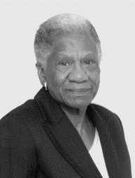
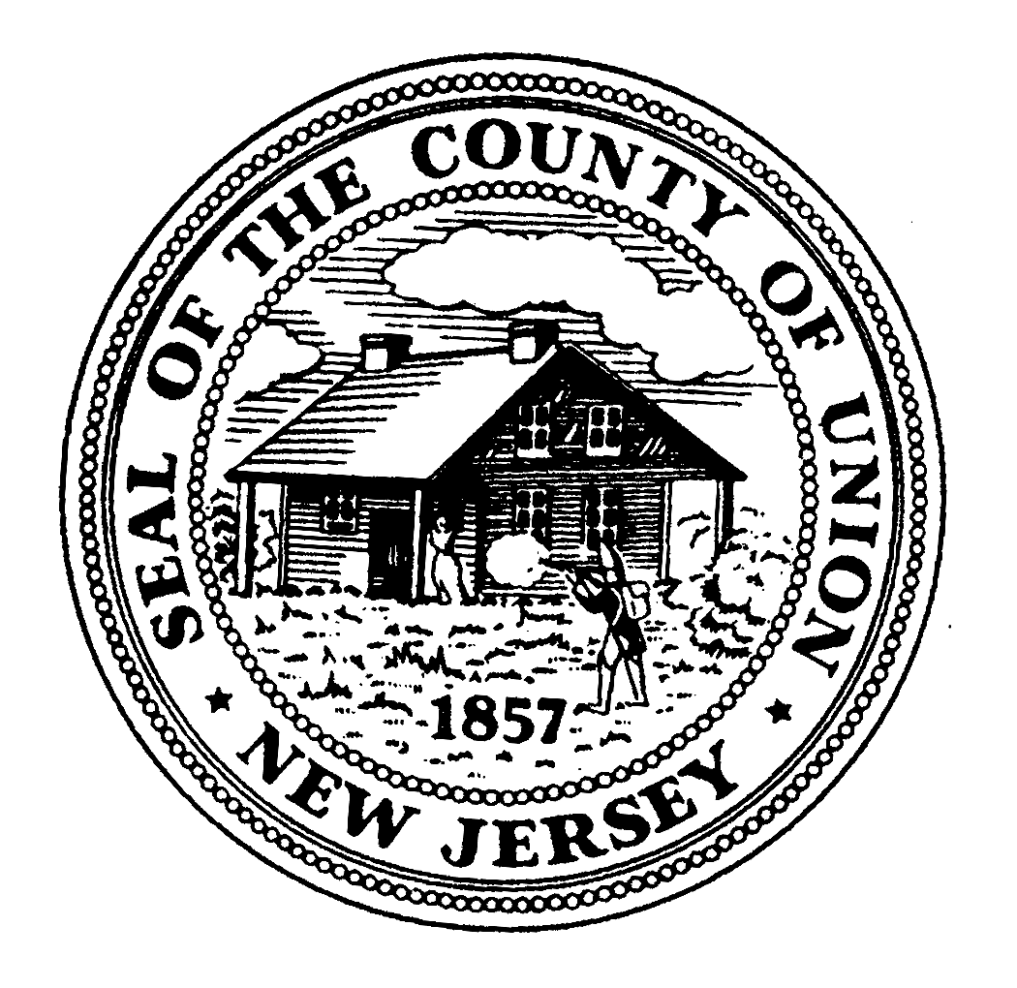
Christopher
Hudak

Vernell
Wright
Bette Jane
Kowalski

Alexander
Mirabella
Mohamed S. Jalloh

Alfred J. Faella, County Manager
Amy Wagner, Deputy County Manager
James Pellettiere, RMC, Clerk of the Board

Department of Parks and Recreation
Ron Zuber, Director
Angel G.
Estrada
Linda
Carter
Sergio Granados
Vice Chairman
Bruce H. Bergen
Chairman
Union County Board of Chosen Freeholders

