––
Union County
We’re Connected to You!

A Service of
The Board of
Chosen Freeholders

UNION COUNTY
OFFICE OF CULTURAL & HERITAGE AFFAIRS
DEPARTMENT OF PARKS & RECREATION

UNION COUNTY HISTORY GRANT PROGRAM

SPECIAL PROJECT GRANT

GUIDELINES and APPLICATION

Calendar Year 2018

January 1, 2018 – December 31, 2018

TYPES OF PROJECTS

- Conservation of Historical Materials
- Educational Initiatives
- Exhibitions
- Public Programs
- Research

Publications
- Digital Media
- Videotape

Funding for this program is made available through the
New Jersey Historical Commission, a division of the
Department of State

UNION COUNTY HISTORY GRANT PROGRAM
Calendar Year 2018: January 1, 2018 – December 31, 2018

INTRODUCTION

The Union County Board of Chosen Freeholders is pleased to offer the Union County History Grant Program. The Union County Office of Cultural & Heritage Affairs (UCOCHA), Department of Parks and Recreation, administers the history grant program funded by the New Jersey Historical Commission (NJHC).

The Guidelines and Application describe how grant funds are used to support special projects or general operating expenses of Union County based non-profit history organizations and units of local government, including libraries and schools that meet the NJHC priorities and criteria.

The Union County Office of Cultural and Heritage Affairs affirms the priorities of the NJHC:

- Help strengthen and further develop existing New Jersey history organizations and programs
- Initiate new programming on New Jersey history
- Improve management and interpretation of historic sites and historical collections
- Expand public understanding and awareness of historical resources
- Increase public and organizational participation in historical programs and activities
- Increase accessibility of historical resources to diverse communities and encourage the exploration of understudied and multicultural aspects of New Jersey history
- Increase the body and quality of information on New Jersey history available to the public
- Preserve materials for the study or preservation of New Jersey history

PROGRAM TIMELINE

Wednesday, April 19 Grant Writing Workshop
Friday, May 26 Deadline for application draft
(Required of first time applicants)
Friday, June 23 Application Deadline
July/August Professional reviewers, C& H Programs Advisory Board Review
September Notification of Awards

For further information contact John W. Prescott, Union County Office of Cultural & Heritage Affairs, 908-436-2912 or jprescott@ucnj.org.

The application is available via e-mail as a writeable Word document (Microsoft Office 2000). Only hard copies of the application may be submitted.

Funding for this program is made available through the
New Jersey Historical Commission, a division of the
Department of State.

General Eligibility Requirements

- Union County based, non-profit history organizations must
- have collections or programming relating to Union County or local history
- be incorporated in the state of New Jersey
- be defined as a non-profit organization under section 501(c) (3) or 501(c ) (4) by the Internal Revenue Service, or pending same
- have been in existence at least two years and demonstrate an ability to provide history
programs and/or services to the public

B. Units of government, including schools and libraries, must
- provide Union County or local history programs, services or activities
- describe in detail the portion of the applicant’s work related to the proposed history program/project

C. Union County based non-history/non-profit organizations must
- be incorporated in the State of New Jersey
- have been in existence at least two years
- be defined as a non-profit organization under section 501(c) (3) or 501(c) (4) of the Internal Revenue Service, or pending same.
- include a copy of the organization’s IRS letter of determination in the original application
packet only
- describe in detail the programs, services and activities that relate to the proposed history program/project
3
Grant recipients must comply with all applicable state and federal laws and maintain good standing with all required state and federal filings. Applicants must show that grant funds will permit them to expand, enhance or introduce Union County and/or local history programs or services. Organizations may not use grant monies as a means to reduce their own expenditures on history programs or services by using these funds as replacement funds.

- Organizations applying for funding under the 2017 Union County Local Arts Grant Program or 2016 HEART Grant Program, may apply to the Union County History Grant Program.

ADDITIONAL REQUIREMENTS

Credit Line: All funded projects must include the following credit line on all printed and publicity materials: This program is made possible by a grant from the New Jersey Historical Commission, a division of the Department of State, and administered by the Union County Office of Cultural & Heritage Affairs.

Technical Assistance Workshops: Grant recipients are expected to attend at least one technical assistance workshop presented by the Office during the grant year.

Cultural Connections: Information on all funded activities must be sent to the Office for inclusion in the calendar of events as soon as program dates are firm, preferably 3 months in advance of the date of the event. Request a “Cultural Connections” form at 908-558-2550 or a writeable form at culturalinfo@ucnj.org.

REVIEW PROCESS

Staff will review and check for completeness of applications received prior to the mandatory deadline. A professional panel will evaluate all proposals against the stated criteria included with these guidelines. The Cultural and Heritage Programs Advisory Board will review applications, professional panel evaluations and determine award amounts. Applicants will be notified of their standing in early fall. Contracts will be signed in September.

DEADLINES

First time applicants are required to submit a draft of their application by Friday, May 26, 2017 for staff review. The narrative and budget pages may be emailed or faxed 908-558-2652. Applicants must submit one original and four copies of the final application and support materials to the Union County Office of Cultural & Heritage Affairs, 633 Pearl Street, Elizabeth, NJ 07202. Application Deadline: Friday, June 23, 2017.

REPORTING AND GRANT PAYMENTS
An Interim Report is due July 7, 2018, covering the period from January 1, 2018 through June 9, 2018. The report must contain a financial accounting and narrative for this period. Should the organization plan any change in the project or expenditure for the remainder of the grant period, the report must address those changes. If the project has been completed, the Final Report may be submitted instead.

A Final Report is due December 5, 2018, and must include a financial accounting and a narrative of activities for the entire grant period of January 1, 2018 through December 1, 2018. If there has been any material change in the organization (staffing, management, facilities and finances) since the award, the final report must discuss those changes.

Documentation of all grant and match expenses must be in the form of paid receipts, canceled checks, or print out of an accounting program (e.g. Quicken) and submitted with the Interim and Final Reports at the end of the grant cycle. Time record sheets may document in-kind donations for volunteer hours; statements of value document donated goods and services. Whether used for “match” purposes or not, in-kind donations must be noted.
Grant funds will be disbursed in two payments. Seventy-five percent will be paid after the contract is signed. After receipt of an acceptable final report, a final payment of 25% of the award will be made. The final payment is a reimbursement payment!

Non-compliance with these requirements and terms may affect both current and future funding.

APPEALS PROCESS

An appeal to the History Grant Program will be entertained only if an applicant can specifically demonstrate that an application was misinterpreted or misunderstood during the evaluation process. The amount of an award will not be grounds for an appeal, and the appeal must be made only on the basis of the information contained in the initial application. Office staff will clarify the appeals procedure for any applicant requiring further information.

Special Project Guidelines

The Maximum Special Project request is $3,500. A dollar for dollar cash match (1:1) is required. A minimum of one-half the grant must be matched in cash. The remaining one-half may be matched with cash and/or in-kind donations, which may include products and services such as volunteer time, donated services, supplies and space, etc. For example, if the grant award is $2,500, the required one-half cash match is a minimum of $1,250. This cash match plus an additional $1,250 combination of cash and/or in-kind donations provides the full minimum match of $2,500. The total cost of your grant project would be $5,000.

The total cost of a project often exceeds the grant amount. Projects may be “overmatched” with additional cash and/or in-kind donations. Applicants should determine the actual costs of the project before deciding on the amount of the grant request which ensures that your organization can meet the cash match requirements.
What Kinds of Projects Are Funded?
1. Presentation and interpretation of public information about state and local history, such as brochures describing the organization’s collection, programs, or services
2. Public programs such as lectures, exhibitions, conferences, symposia, and workshops
3. Classroom instruction at any educational level (including continuing education/training courses for adults)
4. Production of classroom instructional materials
5. Original research and writing, bibliographical essays, historiographies
6. Research in connection with historic preservation projects
7. Research that analyzes the field of New Jersey history, such as the need for long-range planning, resource
Management or heritage tourism
8. Oral history
9. Editorial work (including the updating of important works)
10. Publication (including republication)
11. Film or videotape treatments, scripts, or production
12. Development or enhancement of websites
13. Feasibility studies or planning for large-scale projects in New Jersey history
14. Surveys of New Jersey historical resources
15. Educational components of ceremonies, reenactments, commemorations, or anniversaries of historical e vents
16. Conservation and preservation of historical materials such as manuscripts, books, costumes, furniture, photographs, and other visuals of historic importance that will be available to the public
17. Fellowship support
18. Microfilming and the production of finding aids to collections
19. Genealogical projects resulting in research tools (indexes, cemetery locators, collective regional resources, publicly accessible databases) of use to the wider historical community
20. CD-ROMs or other digital projects
21. Newspaper microfilming

What Kinds of Expenses Are Covered?
1. Microfilming
2. Travel and/or maintenance while conducting research
3. Archival or research library user fees
4. Oral history tape transcription
5. Wages or stipends for project personnel, such as conservators, curators, educational consultants, and researchers
6. Honoraria, travel, and maintenance for speakers
7. Supplies to be used in the project (such as audiotapes, videotapes, storage materials, office supplies, and materials for educational projects)
8. Materials for fabricating and installing exhibitions
9. Payment of exhibition loan fees and shipping costs
10. Archival folders, boxes and other materials for conservation of historical materials such as manuscripts, books, costumes, and photographs
11. Typesetting, printing, and binding
12. Photography and photocopying
13. Production of promotional or advertising materials
14. Equipment rental (call the office for rentals in excess of $1000)
15. Equipment purchases with the following restrictions: Only institutions and organizations may use grant
funds to purchase major items, such as computers or video cameras. All grant recipients, however, may use grant funds to purchase items such as inexpensive tape recorders and computer software.
16. Travel expenses with the following limits: a. Automobile travel: $.31 per mile
17. Speakers’ honoraria in the following amounts: a. Keynote speaker, up to $750. One keynote speaker per program
b. Main speaker, up to $500
c. Chairperson or moderator, up to $150
d. Panelist, up to $125

What Is Ineligible: Who May Not Apply?
1. Agencies of the federal or state government. This category does not include state colleges or universities.
2. Organizations/individuals who have received a grant from the Historical Commission and failed to submit a final report on the project
3. Individuals engaged in an active project funded by the Historical Commission
4. Organizations with operating budgets of less than $150,000 that are engaged in an active project funded by the Historical Commission
5. Organizations that do not practice policies of equal access and non-discrimination

What Is Ineligible: What Kinds of Projects Cannot Be Funded?
1. Projects that do not relate to New Jersey history
2. Project work that is completed before the submission of the application. For example, a request to typeset and print a completed manuscript is eligible; a request to pay an author who produced the manuscript, after the manuscript has already been written, is not.
3. Restoration or preservation of structures
4. Purchase of collections, furniture, costumes, artifacts, or other items for collections
5. Construction, restoration, preservation of gravestones, commemorative statues, plaques, and other items
6. Projects of federal or state government agencies
7. Conservation of materials owned by the federal government
8. Conservation of collections of unidentified photographs
9. Projects which are not accessible to the general public
10. Performances, fiction, and poetry
11. Publication of coloring books, cookbooks, and calendars
12. Genealogical projects such as genealogies of specific families (unless applicants can demonstrate the usefulness of the projects to the understanding of New Jersey history)
13. Videotaping or audio-taping of public programs, or oral history interviews without the production of transcripts to be made accessible to the public

What Is Ineligible: What Kinds of Expenses are Ineligible?
1. Purchase of items for collections
2. Purchase of books or prepackaged instructional materials unless the applicant can demonstrate that such expenditures are warranted
3. Purchase of refreshments for the project’s audience
4. Field trips if that is the only component of the project

The Narrative

The narrative is the heart of the application. You must assume that the reader knows nothing about the project or the topic covered. The narrative should coincide with the budget page. Please describe how you determined the costs shown on the major line items of your budget. For example, tell how you projected the costs of printing, postage, supplies and materials and any paid advertising. Explain your major projected income sources. Be sure your projected expenses are based on research. The budget page tells your project’s story in numbers; the narrative in words.
Grant reviewers are most impressed with succinct narratives. When writing the narrative please have the evaluation criteria, against which the application will be measure, on hand. Section headings (based on the numbering of the items below) are recommended. Limit: three to five pages.

Begin narrative with overview of organization and history related activities.

Use the BOLDFACE words below, in the order in which they appear, as section headings in your narrative. This will help you develop a clear and concise narrative.

- WHAT is the project? WHY is it worth doing? Tell how it relates to the organization’s mission. State the goals and objectives of your project. Is it new or ongoing programming? HOW was the project selected? Discuss the project planning process including how you determined the interests and needs of the community or if hiring a consultant, your organizational needs.
- WHO is involved with the project? Provide the name and history related qualifications or credentials of person(s) responsible for overseeing the project. If there is a committee, name its members and discuss credentials. Give the name and relevant experience of professionals hired through the grant. Provide a clear statement of responsibilities of each. Describe how you selected the professionals. Be sure to include all resumes.
- How much will the project cost? How will you spend the grant funds? Be very specific. This is the financial narrative: describe in words the line items shown on the budget pages. Discuss why these funds are needed, how they were determined and how they will be spent. This information explains the figures presented in the budget.
- WHERE and WHEN will the project take place? How many events will take place? Who will BENEFIT from your project? How will they benefit? Describe the demographics of your community, and the participants and audience for this project. Estimate the number of individuals directly served by your project. Is this project in addition to your usual public hours? Please explain.
- How will you ADVERTISE and PROMOTE the project? Discuss your publicity plan; list the specific media you will use. Describe plans to expand diversity in audience members and membership.
- What is the TIMELINE of your project? Include with the support material a complete timeline in monthly increments, beginning with grant approval through the conclusion of the project.
- How will you EVALUATE the success, benefits and failures of your project?
- How does your organization comply with the AMERICANS WITH DISABILITIES ACT with regard to accessibility of the facilities where the project will take place? Identify any program accommodations such as assistive listening devices, audio description, large print programs, etc. Mention your accomplishments or plans in the area of accessibility.
Does this program promote the value of HISTORY EDUCATION and raise PUBLIC AWARENESS of historic resources? Give specific examples.

UNION COUNTY HISTORY GRANT PROGRAM

Calendar Year 2018 January 1, 2018 - December 31, 2018

Special Project: Application Form

Submit 1 original and 4 copies (total 5) of the completed application to: Union County Office of Cultural and Heritage Affairs, 633 Pearl Street, Elizabeth, NJ, 07202 by Friday, June 23, 2017.

Project Title:
Applicant/Organization:
Address:
Phone #: ( ) Fax: ( )
E-mail:
Website:
Contact Person: Title:
Address:
Phone #: ( ) Fax: ( )
E-mail:
Federal Tax Exemption #”
PROJECT SUMMARY (No more than 100 words)

BUDGET SUMMARY
A. Grant Amount Requested $

B. 1:1 Cash Match Requirement: $
(Minimum 50% or ½ of the grant request must be
matched in cash by the grantee)

C. In-Kind Match: $
(50% or ½ of the grant may be matched in donated
services or products

D. Cash Total:
(A + B) $

E. TOTAL COST OF PROJECT (C+D): $

In-Kind Contributions

All applicants must complete this form even if you are not using In-Kind Contributions for your match. *Contributions are donated services of volunteers/individuals, goods and services, which have a documented cash value. Provide an estimate of what the costs would be if, for example, you have donated space, a volunteer accountant or treasurer, volunteer administrator, etc.

Nature of Contribution Estimated Cash Value

Total In-Kind Contributions $

*An example of an in-kind contribution is your volunteer accountant who may normally charge $150 an hour for his or her services.

Project Director:

Street Address:

Daytime Telephone:

Position with Applicant/Organization:

Signature________________________________________________ Date______________

AUTHORIZATION

I understand that these pages and attachments constitute part of this application. I certify that all statements in this application are true to the best of my knowledge; and I hereby release the Board of Chosen Freeholders of the County of Union, its employees, and agents from any liability and/or responsibility concerning any submission of materials to the program. I further certify that any funds received under the Union County History Grant Program will be used exclusively for the purpose set forth in this application. I understand and agree that submission of an application signifies intention to comply with Title VII of the Civil Rights Act of 1964 (PL 88-352), with Labor Standards under Section 501 of the National Foundation on the Arts and Humanities Act of 1965 (PL 185-209), Title IX of the Education Amendments of 1972, Section 504 of the Rehabilitation Act of 1973, and the Americans with Disabilities Act of 1990.

Authorizing Official
________________________________________________________________________________
Name & Title

________________________________________________________________________________
Signature Date

Chief Financial Officer:

Organization’s Annual Budget $:

Number of Members:

This application is available as a writeable Word Document (Microsoft Office 2000).
Questions: (908) 558-2550; NJ Relay Users 711.

Special Project: Budget Form
Category of Expenditure | Grant Funds  Requested | Matching Funds/Cash | Cash Total  (A + B) | Matching  In-Kind
 | A | B | C | D
Project Director
Professional services
Speaker fees
Space Rental
Typesetting/printing
Publicity
Transportation
Salaries, fringe benefits
Materials & supplies
Postage, telephone
Purchase/rental of
Equipment
Other (specify)

Other (specify)

TOTALS
(See Special Project Guidelines, First Paragraph)
It is not necessary to have a figure on each line. Itemize the above expenses in the budget narrative

EVALUATION CRITERIA

A professional history panel and the history committee of the UCOCHA Advisory Board will review each application using the following standards:

History Content
- Credentials of personnel as demonstrated by support material and resumes
- Activities that further the applicant’s history related goals and objectives
- Projects that promote education, awareness and appreciation for the importance of local and county history

Administrative Ability
- Exhibits sound management (volunteer or paid)
- Demonstrates ability to deliver services effectively
- Documents interest from intended audience (explains how projects are selected)

Financial Management
- Demonstrates fiscal responsibility
- Presents a realistic budget
- Shows diverse funding sources

Outreach and Promotion
- Demonstrates effective and timely publicity efforts that widely promote the organization and activities
- Demonstrates effort to involve individuals and groups from a diversity of backgrounds and communities
- Demonstrates effort to provide local and Union County history programs and activities with culturally diverse historic content and appeal to underserved communities
- Addresses accessibility issues in compliance with the Americans with Disabilities Act (ADA)

For your additional information:

History content may be demonstrated by support material – bios and resumes – by what you do or by what the people you hire do. Be clear about the history credentials of the personnel, both professional and volunteer, involved in your program.

Administrative capacity will be demonstrated by the organization of your proposal, its content, neatness and completeness. Accurate budget calculations are important; be sure to check your addition. Planning documents are helpful.

Proof reading by others is strongly recommended!
Special Project Application Checklist

Applicant Organization:

This checklist (completed, signed and dated) must accompany the original (labeled) and four (4) copies of the application by Friday June 23, 2017. Check each item when you have provided the requested information. We will return a countersigned copy to you indicating receipt of your application.

Assemble the grant application, as indicated below into five individual POCKET FOLDERS (mark the original). Please use 12-point type and number all pages in the upper right hand corner. Identify the folder/ packet containing the original signatures and the one copy of the Internal Revenue Service letter of tax exemption status. Only complete application consisting of the following elements will be reviewed:

Right Side of Pocket Folder:

Application check-list (with original folder only; do not staple to application)
- Grant application form
- Narrative
- Project budget from

Left Side of Pocket Folder:

- Resumes of key project personnel---paid or volunteer staff, consultants, speakers
(3 page limit per person)
- Support materials; brochures, catalogues, publications, press clippings and study guides, and other items that illustrate the operation and program and that support claims made in the narrative. Limit the materials to no more than three items.
- Certification of support for educational initiatives from the school
- Vendor price quotes and work descriptions, where applicable (conservation proposals, researchers, grant writers, collections care, microfilming)
- Documentation of commitment from any consultant or speaker with a description of the work to be done and his/her fee
- Internal Revenue Service letter of tax exemption Section 501 (c) 3
(copy in original folder only)

I certify that I have reviewed and checked the application and that it is complete:

_________________________________________________________________________
Signature Title Date

Received by Union County Office of Cultural & Heritage Affairs Representative:

_________________________________________________________________________
Signature Title Date

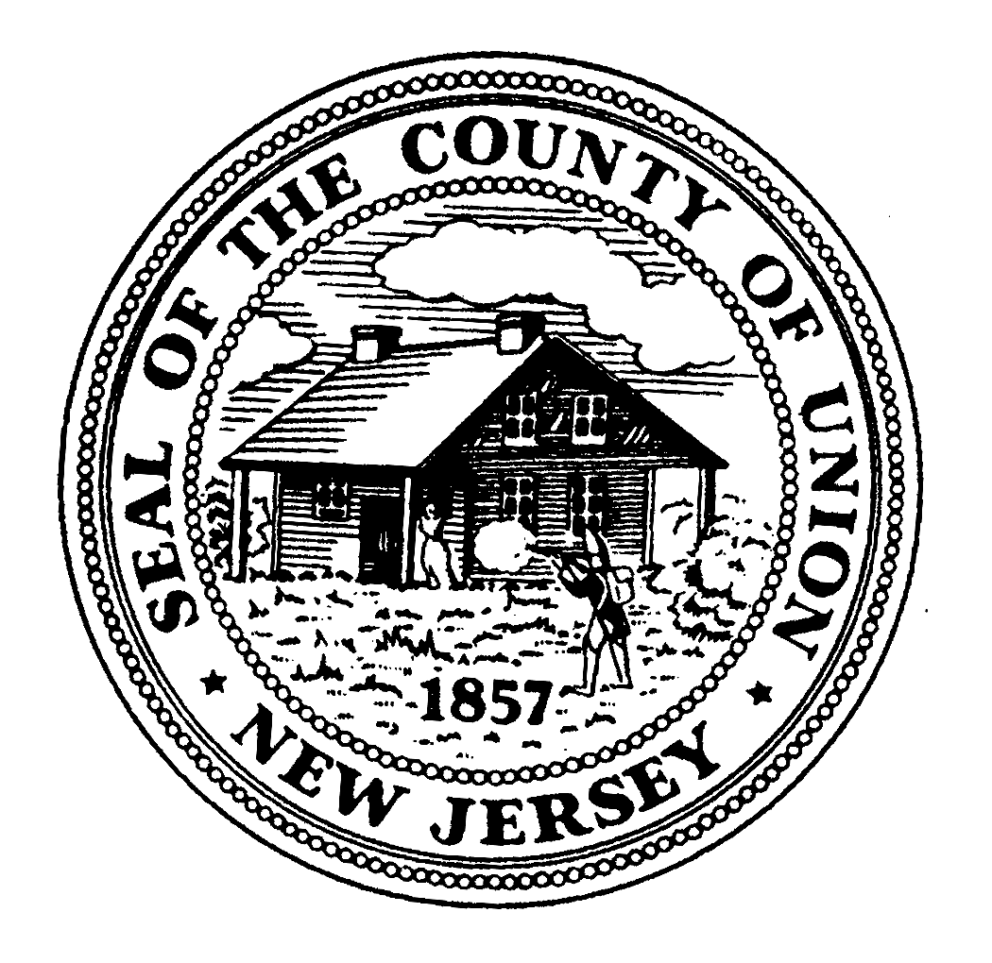
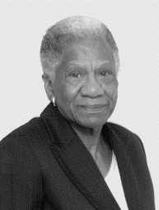
Christopher Hudak
Union County Board of Chosen Freeholders
Bruce H. Bergen
Chairman
Sergio Granados
Vice Chairman
Linda
Carter
Angel G.
Estrada
Mohamed S. Jalloh

Bette Jane
Kowalski
Alexander
Mirabella
Vernell
Wright
Alfred J. Faella, County Manager
Amy Wagner, Deputy County Manager
James Pellettiere, RMC, Clerk of the Board

Department of Parks and Recreation
Ron Zuber, Director

