FORM M
BUSINESS REGISTRATION
(MANDATORY PROPOSAL SUBMISSION)
(FOR PROFIT PROPOSERS ONLY)

P.L. 2009, c.315, requires that effective January 18, 2010; a contracting agency must receive proof of the PROPOSER’s business registration prior to the award of a contract. However, the proof must show that the PROPOSER was in fact registered with the State of New Jersey Department of the Treasury, Division of Revenue and obtained the business registration prior to the receipt of this RCCP.

If subcontractors are named in the proposal, proof of the business registration for each must be provided prior to the award of a contract. Similarly to the PROPOSER, the proof must show that each subcontractor was registered with the State of New Jersey Department of the Treasury, Division of Revenue and obtained the business registration prior to the receipt of this RCCP.

Proof of business registration shall be:
- A copy of a Business Registration Certificate issued by the Department of Treasury, Division of Revenue; or
- A copy of the web printed version provided by the NJ Division of Revenue.

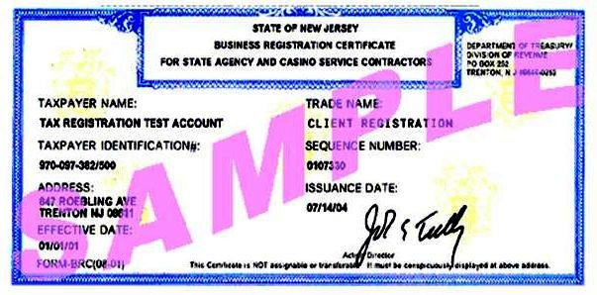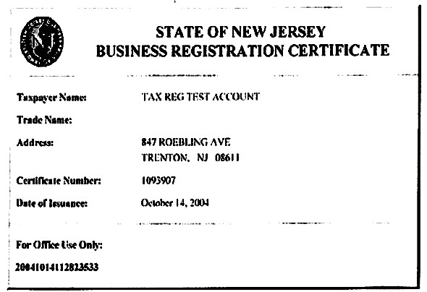

ATTACH BRC HERE

